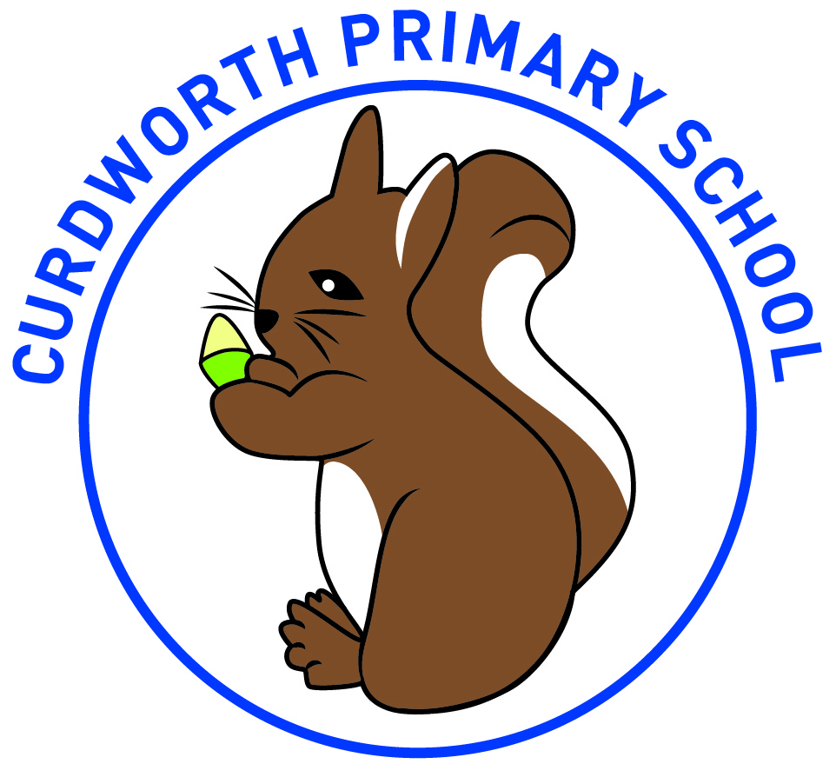
Curdworth Primary School
Common Exception Words – Year 1

a
are
ask
be
by
come
do
friend
full
go
has
he
here
his
house
I
is
love
me
my
no
of
once
one
our
pull
push
put
said
says
school
she
so
some
the
there
they
to
today
was
we
were
where
you
your

