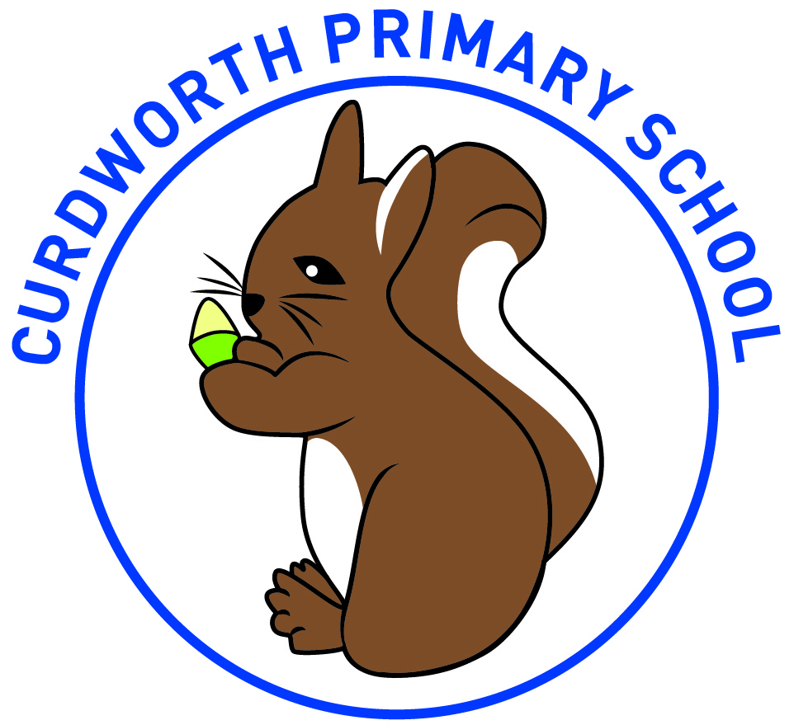
Curdworth Primary School
Common Exception Words – Year 2

after
again
any
bath
beautiful
because
behind
both
break
busy
child
children
Christmas
class
climb
clothes
could
cold
door
even
every
everybody
eye
fast
father
find
floor
gold
grass
great
half
hold
hour
improve
kind
last
many
mind
money
most
move
Mr
Mrs
old
only
parents
pass
past
path
people
plant
poor
pretty
prove
should
steak
sugar
sure
told
water
whole
who
wild
would

