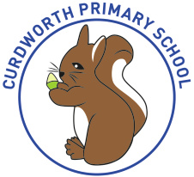
Curdworth Primary School
Recommended Daily Timetable
Dear Children,
It is important that whilst you are away from school you try your hardest to carry on with learning at home. The tasks your teachers and grown-ups set you will help you to keep making BRILLIANT progress. Although we are not with you, you can email your teachers or message us on our school Twitter page @curdworthschool so that we can see your AMAZING LEARNING.
Below is an idea of what your learning from home timetable might look like.
Good luck xxx
Time | Activity | Suggested Activities
Before 9am | Wake Up | Have breakfast  Get dressed  Brush your teeth  Make your bed  Tidy your room
9am – 10am | Exercise Time | Fresh air outside  Yoga  Wake and Shake Activities
10 am – 11am | Academic Time | Learning set by your teachers
11am – 12pm | Creative Time | Any creative tasks set by your teacher  Lego/Construction  Drawing/Painting/Craft  Baking  Singing/Music
12pm – 1pm | Lunch/Relax | TV  Computer/ iPad  Reading  Remember to stay safe online
1pm – 1.30pm | Exercise Time | Complete an activity from your class PE menu  Exercise outside  Any active tasks set by your teacher
1.30pm – 2.30pm | Academic Time | Learning set by your teachers
2.30pm – 3pm | Quiet Time | Daily Reading set by your teacher  Play a board game  Jigsaw puzzle
3pm – 4pm | Fresh Air | Outdoor play  Take a walk  Gardening/nature
4pm – 5pm | Electronics Time | TV  Computer/ iPad  Reading  Remember to stay safe online
5pm – 6pm | Dinner time | Have dinner  Relax  Talk about your day

