Curdworth Primary School Uniform
At Curdworth Primary School, we want children to take pride in their appearance, look smart and feel good about themselves. Wearing the correct school uniform promotes self-respect and respect for their school, creating a strong sense of school community.
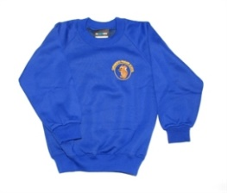
Our school uniform is:
- grey skirt, grey pinafore dress or grey trousers
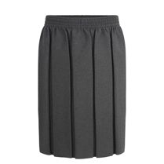
- white blouse or polo shirt
- royal blue school sweatshirt, cardigan or school fleece
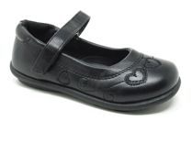
- white/grey/black socks or grey/black tights
- black shoes (NO BLACK TRAINERS OR OPEN TOE SANDALS)
- royal blue and white gingham check summer dress

Outdoor wear
- waterproof coat
- school fleece
- hat, scarf and gloves

Sports wear
- family group coloured t-shirt (this can be with or without the school logo)
- black joggers/leggings (black shorts can be worn in the summer)
- outdoor sports trainers (that support feet during physical activities such as running, jumping and safe landing)
- PE hoody or school cardigan/jumper (this can be with or without the school logo)

Jewellery/Accessories

small stud earrings only, no other jewellery allowed

plain, black or blue headbands or hair clips

Reminders
- Please note that black trousers, skirts and dresses are NOT part of our school uniform.
- All clothing should be clearly marked using name tags or a water-resistant marker pen (please note: biro washes off over time).

Please see the following links to companies where the school uniform can be purchased:
- My Clothing:
https://myclothing.com/curdworth-primary-school/8109.school
- Trutex: https://www.trutex.co/
- Clive Mark https://clivemark.co.uk

