

**CPS Newsletter Issue 10**

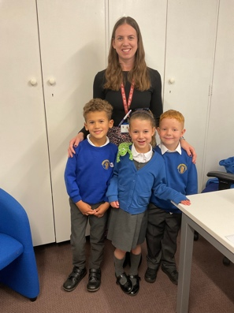

**Happy Birthday!**

Jesse, Eli, Poppy and Jobe!



**School Dates**

**13.11.23** Anti-Bullying Week starts.

**20.11.23** Odd Sock Day

Reception Vision Screening

Parent Consultation bookings open

**NEW DATE** Reception Open morning 9.15-10.15

**23.11.23** Phonics Parent Workshop 9-9.45

**28.11.23** Reception Open morning 9.15-10.15

**29.11.23** Whole School Panto Trip

**30.11.23** Squirrels Class assembly

**INSET DAY** Fri 1st Dec 2023

**07.12.23** Christmas Jumper & Dinner Day – Christmas Fair 3.30 p.m. – 5.30

**08.12.23** Reception Nativity 2.45 **11.12.23** Book Fair week & Parent Consultations 1.30 – 5.30

**14.12.23** Year 1 & 2 Nativity 2.30

**18.12.23** Parent Consultations 1.30 – 5.30

**19.12.23** Christmas Craft Morning

**22.12.23** Carol Concert at St Nicholas at 2.15

**CHRISTMAS BREAK**

Mon 25th Dec to Mon 8th Jan

Children return Tuesday 9th Jan 2024

**What has been happening at Curdworth this week….**

**Year 1 Phonics Workshop**

It was a fantastic turn out for the Year 1 phonics

workshop on Thursday. It was a pleasure to be

able to share with you how phonics and reading

is taught in Year 1 and offer advice on how you

can continue to support your child at home.

Thank you for your engagement during the

session – it was great to have so many questions being asked. I’m sure you can all agree how wonderful the children that took part in the live session were – that was a reflection of phonics in action at Curdworth. Well done to Jax, Isla, Zachary and Harper for demonstrating their brilliant phonics skills.

If you haven’t already, please can you complete the short survey to support us in improving future workshops.

<https://forms.office.com/e/hPMJtqQYYP>

**Community Advocate**

Laura Heeley will be on the morning gate every Wednesday this half term to enhance communication between the school and parents. Should you want to raise any issues or share successes, please see this as an opportunity to do so.

**Remembrance Day Exhibition**

Squirrels Class have worked incredibly hard this week to put on an exhibition for the school this afternoon. They started off their week with having Paul Jaques and David Vaux from the Staffordshire Regiment Museum in to show them and talk to them about some WWI artefacts. They have also created poetry and explanation texts to use in their exhibition as well as a whole class art installation. It was amazing to see so many parents attend the exhibition with their children, learning facts from the children. Children from other class got to share their learning on Remembrance too. It was a great community event to honour our history.

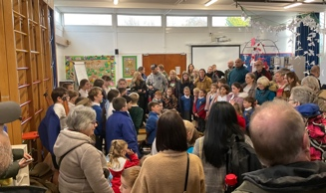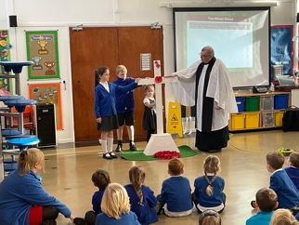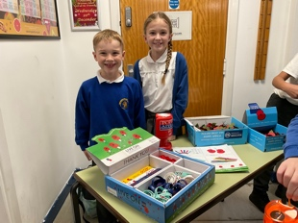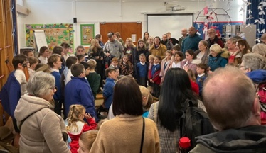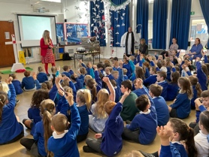

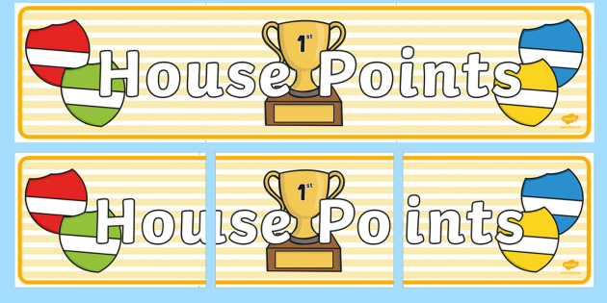

|  |  |  |
| --- | --- | --- |
| **1st** | **Ford** | **194** |
| **2nd** | **Jaguar** | **183** |
| **3rd** | **Vauxhall** | **173** |
| **4th** | **Rover** | **165** |

**⭐️ATTENDANCE STARS ⭐️**

School Target: **97%**

School Actual: **96.7%**

Best Year Group this week…

**Year 2 and Year 5 with 100% 😊**

**Class Dojo Badges**

**Blue badge** -

50 Class dojos 🔵

**Green badge** -

150 Class dojos 🟢

**Red badge** -

250 Class dojos 🔴

**ACHIEVERS this week are…**

Sophie W, Ruby, Abel, Kiara, Willow, Arlo R, Indie M, Tristan, Zachary, Harper, Jaien, Arlo S, Cody, Louie, Charlie K, Harley

🔵

Teddy

🟢

*They will receive their badges in the assembly next week.*

**Jamf**📲

Thank you for your support in the launch of *Learning Futures.*

Parents can now download **JAMF** - the parenting app that allows you to be in control over the children's iPads when at home.

You will be able to create rules and restrictions on the amount of time and the types of apps you would like your child to access at home.

You will first need to download the Jamf App.

This 'How To' video will help you set this up.

<https://www.youtube.com/watch?v=tFAGO_jOk-w>

Please get in touch should you need assistance.





**iPad and Home Learning Reminder**

All children were reminded today, in assembly, the amount of time they are expected to spend on home learning after school.

**TTRS** – only 10 minutes at least 3 times a week (Y2-6)

**Maths** – set on Showbie approximately 20 minutes once a week.

**Reading** – approximately 20 minutes on Reading Plus **OR** reading your library book/other reading material at home every day.

**Spellings** – approximately a 10-minute video or spelling words sent via Showbie to practise on paper.

**All other time is at parent’s discretion, and iPads can be locked using Jamf.**

**If you would like support setting up Jamf please let me know.**

Children’s University

Bronze Award, Certificate & Diploma WINNERS

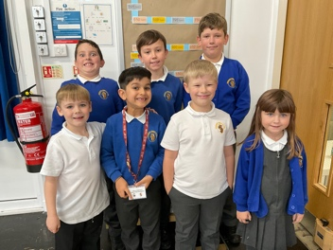

LEADERBOARD

A competition will be set up for next week. Which year group will be top of the leaderboard?



***Uniform Expectations – a gentle reminder***

* Small stud earrings only
* Plain, black or blue headbands or accessories
* Shoulder length hair to be tied up (for safety and hygiene reasons)



