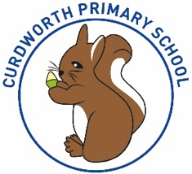

**CPS Newsletter Issue 11**

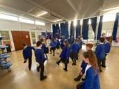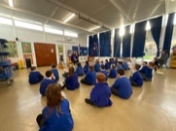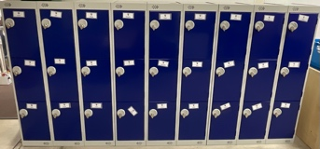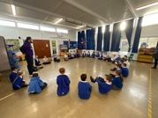!!

CURDWORTH CHAMPIONS

A huge congratulations to our super champs this week!

😊 Myla – Reception Charlie K – Year 1 😊

😊 Sienna T – Year 2 Hugo L – Year 3😊

😊Ruby M – Year 4 Squirrels Class 😊

**What has been happening at Curdworth this week….**

**Bottle donations – Non-Uniform Day**

On Monday 20th November, children can wear their own clothes and odd socks for a bottle donation for our PTFA Christmas Fair. These can be sent in with your child or dropped off at the school office.

**Anti-bullying Week**

We started off our week with One Kind workshops

across school for anti-bullying week, led by a drama

group. The focus of the workshop was around using kind

words. To end anti-bullying week, Curdworth our holding

their own Odd Sock Day event alongside the non-uniform

day, on Monday 20th November.

**Parents Consultations**

These will be available to book on MCAS from 10am on

Monday 20th November. These are on a first come, first served basis.

**Lockers**

The children’s coat pegs have been replaced with

lockers across school, so the children have a tidy

place for their belongings. The children have been

very excited about these!

**School Dates**

**20.11.23** Own clothes & Odd Sock Day

Reception Vision Screening

Parent Consultation bookings on MCAS

Reception Open morning 9.15-10.15

**23.11.23** Phonics Parent Workshop 9-9.45

**28.11.23** Reception Open morning 9.15-10.15

**29.11.23** Whole School Panto Trip

**30.11.23** Pyjama Day for PTA

**INSET DAY** Fri 1st Dec 2023

**05.12.23** Squirrels Class assembly **\*changed from 30.11\***

**07.12.23** Christmas Jumper & Dinner Day – Christmas Fair 3.30 p.m. – 5.30

**08.12.23** Reception Nativity 2.45 **11.12.23** Book Fair week & Parent Consultations 1.30 – 5.30

**14.12.23** Year 1 & 2 Nativity 2.30

**18.12.23** Parent Consultations 1.30 – 5.30

**19.12.23** Christmas Craft Morning

**22.12.23** Carol Concert at St Nicholas at 2.15

**CHRISTMAS BREAK**

Mon 25th Dec to Mon 8th Jan

Children return Tuesday 9th Jan 2024

**⭐️ATTENDANCE STARS ⭐️**

School Target: **97%** School Actual: **96%**

Best Year Group this week…

**Year 1 & 5 - 100% 😊**

***If you want to know your child’s % to date, you can find this information on MCAS.***

**Happy Birthday!**

No birthdays this week



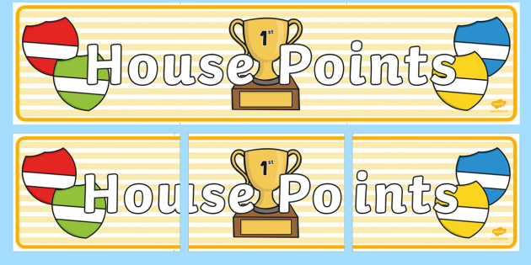

|  |  |  |
| --- | --- | --- |
| **1st** | **Rover** | **232** |
| **2nd** | **Ford** | **228** |
| **3rd** | **Vauxhall** | **221** |
| **4th** | **Jaguar** | **195** |

**Jamf**📲

Thank you for your support in the launch of *Learning Futures.*

Parents can now download **JAMF** - the parenting app that allows you to be in control over the children's iPads when at home.

You will be able to create rules and restrictions on the amount of time and the types of apps you would like your child to access at home.

You will first need to download the Jamf App.

This 'How To' video will help you set this up.

<https://www.youtube.com/watch?v=tFAGO_jOk-w>

Please get in touch should you need assistance.

**Class Dojo Badges**

**Blue badge** -

50 Class dojos 🔵

**Green badge** -

150 Class dojos 🟢

**Red badge** -

250 Class dojos 🔴

**ACHIEVERS this week are…**

Mylo, George, Phoenix M-H, River, Ryan, Scarlett P, Penny, Marni, Seb, Isla L

🔵

Who will be the next green badge achiever?

🟢





**iPad and Home Learning Reminder**

All children were reminded today, in assembly, the amount of time they are expected to spend on home learning after school.

**TTRS** – only 10 minutes at least 3 times a week (Y2-6)

**Maths** – set on Showbie approximately 20 minutes once a week.

**Reading** – approximately 20 minutes on Reading Plus **OR** reading your library book/other reading material at home every day.

**Spellings** – approximately a 10-minute video or spelling words sent via Showbie to practise on paper.

**All other time is at parent’s discretion, and iPads can be locked using Jamf.**

**If you would like support setting up Jamf please let me know.**

LEADERBOARD

1st Year 5

2nd Year 6

3rd Year 3

4th Year 4

5th Year 2

Top Rockers:

Rhys

Karina

Hugo M

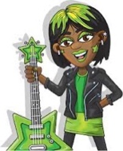

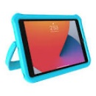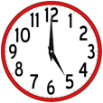

***Uniform Expectations – a gentle reminder***

* Small stud earrings only
* Plain, black, or blue headbands or accessories
* Shoulder length hair to be tied up (for safety and hygiene reasons)

