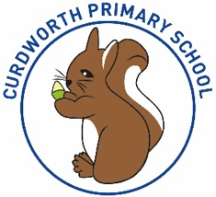

**CPS Newsletter Issue 12**

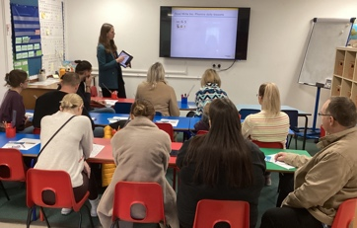

**What has been happening at Curdworth this week….**

**Reception Phonics Workshop** - It was

fantastic to see so many Reception

parents at the phonics workshop on

Thursday. It was great to be able to share

with you how phonics is taught in Reception and to offer advice on how you can continue to support your child at home. It was great to see the children demonstrating what phonics is like at Curdworth during the live session.

If you haven’t already, please can you complete the short survey to support us in improving future workshops.

<https://forms.office.com/e/57pwf7Td7T>

**Reading Ambassadors** – We are still looking for some Reading Ambassadors across school. If your child is interested, please see the post on the school story.

**Orchard Blyth Gift tags** – If you have signed up to give a gift to a resident of the Orchard Blyth care home, you should have received your gift tag. Please contact Mrs Jennings if you do not have yours. The post about this is on the school story on Class Dojo

**School Pantomime** - On Wednesday, the whole school are visiting the Lichfield Garrick Theatre to watch Beauty and the Beast. Snacks will be provided for the children. There will be no clubs after school on this day. A message will be sent on Class Dojo when we leave the theatre to inform you of our arrival time back at school.

Have a lovely weekend,

***Mrs Kang & Miss Gibbs*** 😊

**School Dates**

**28.11.23** Reception Open morning 9.15-10.15

**29.11.23** Whole School Panto Trip

**30.11.23** Pyjama Day for PTA – chocolate or £1 donation.

**INSET DAY** Fri 1st Dec 2023

**05.12.23** Squirrels Class assembly **\*changed from 30.11\***

**07.12.23** Christmas Jumper & Dinner Day – Christmas Fair 3.30 p.m. – 5.30

**08.12.23** Reception Nativity 2.45 **11.12.23** Book Fair week

Parent Consultations 1.30 – 5.30 p.m.

**14.12.23** Year 1 & 2 Nativity 2.30

**18.12.23** Parent Consultations 1.30 – 5.30 p.m.

**19.12.23** Christmas Craft Morning

**22.12.23** Carol Concert at St Nicholas at 2.15 p.m. Children leave from church.

**CHRISTMAS BREAK**

Mon 25th Dec to Mon 8th Jan

Children return Tuesday 9th Jan 2024

**⭐️ATTENDANCE STARS ⭐️**

School Target: **97%** School Actual: **96%**

Best Year Group this week…

**Year 4 & 5 - 100% 😊**

***If you want to know your child’s % to date, you can find this information on MCAS.***

CURDWORTH CHAMPIONS

A huge congratulations to our super champs this week!

🌟Justin – Reception🌟

🌟Scarlett– Year 1🌟

🌟Florence – Year 2🌟

🌟Minnie – Year 3🌟

🌟Seb – Year 4🌟

🌟Alexandra - Year 5🌟

🌟Theo - Year 6🌟

**School dinners**

It has now been 4 months since Relish was introduced as the ATLP lunch ordering portal and all parents should now have an account. Unfortunately, we still have a considerable number of pupils who are still ordering lunch during registration, despite several reminders. This applies to all year groups. Please ensure that school lunches are ordered in advance to ensure that teachers can move forward with their lessons for the day.

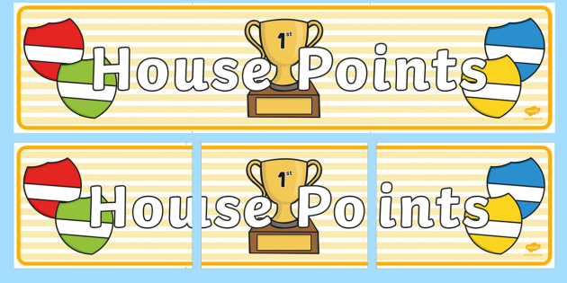

|  |  |  |
| --- | --- | --- |
| **1st** | **Ford** | **206** |
| **2nd** | **Jaguar** | **164** |
| **3rd** | **Vauxhall** | **135** |
| **4th** | **Rover** | **129** |

**Class Dojo Badges**

**Blue badge** -

50 Class dojos 🔵

**Green badge** -

150 Class dojos 🟢

**Red badge** -

250 Class dojos 🔴

**ACHIEVERS this week are…**

Indi B, Amaya, Huxley

🔵

Ralph, Jobe

🟢



**Jamf**📲

Thank you for your support in the launch of *Learning Futures.*

Parents can now download **JAMF** - the parenting app that allows you to be in control over the children's iPads when at home.

You will be able to create rules and restrictions on the amount of time and the types of apps you would like your child to access at home.

You will first need to download the Jamf App.

This 'How To' video will help you set this up.

<https://www.youtube.com/watch?v=tFAGO_jOk-w>

Please get in touch should you need assistance.



**Happy Birthday!**

Bodhi!



**iPad and Home Learning Reminder**

All children were reminded today, in assembly, the amount of time they are expected to spend on home learning after school.

**TTRS** – only 10 minutes at least 3 times a week (Y2-6)

**Maths** – set on Showbie approximately 20 minutes once a week.

**Reading** – approximately 20 minutes on Reading Plus **OR** reading your library book/other reading material at home every day.

**Spellings** – approximately a 10-minute video or spelling words sent via Showbie to practise on paper.

**All other time is at parent’s discretion, and iPads can be locked using Jamf.**

**If you would like support setting up Jamf please let me know.**

LEADERBOARD

1st Year 5

2nd Year 3

3rd Year 4

4th Year 6

5th Year 2

Top Rockers:

Rhys

Rory

Hugo M

