

**CPS Newsletter Issue 13**

**⭐️ATTENDANCE STARS ⭐️**

School Target: **97%**

School Actual: **94.7%**

Best Year Group this week…

**Year 1 with 99.2% 😊**

***If you want to know your child’s % to date, you can find this information on MCAS.***

**School Dates**

**INSET DAY** Fri 1st Dec 2023

**05.12.23** Squirrels Class assembly

**07.12.23** Christmas Jumper & Dinner Day – Christmas Fair 3.30 p.m. – 5.30

**08.12.23** Reception Nativity 2.45 & Orchard Blythe care home visit to school

**11.12.23** Book Fair week

Parent Consultations 1.30 – 5.30 p.m.

**14.12.23** Year 1 & 2 Nativity 2.30

**18.12.23** Parent Consultations 1.30 – 5.30 p.m.

**19.12.23** Christmas Craft Morning

**22.12.23** Carol Concert at St Nicholas at 2.15 p.m. Children leave from church.

**CHRISTMAS BREAK**

Mon 25th Dec to Mon 8th Jan

Children return **Tuesday 9th Jan 2024**

**09.01.24** School reopens to pupils

**10.01.23** 100% Autumn Term attendance breakfast

**01.02.24** PTFA Movie Night 3.30 – 5.30pm

**05.02.24** Children’s Mental Health Week & Reception Bikeability

**What has been happening at Curdworth this week….**

**Panto**

Thank you to PTFA for organising a fantastic trip

and helpers

**Orchard Blyth Gifts** –Please could your gifts be in school no later than Friday 8th December, ahead of the residents’ visit to the school during w/c 11th December.

**Parent Consultations 11th and 18th December 1.30 p.m. to 5.30 p.m.** Please remember to book your appointment via the Parents Evening section on MCAS. Limited appointments remain for 11.12.23 but there are still several for 18.12.23. If you are having issues with booking a slot, please contact the school office for assistance.

Have a lovely weekend,

***Mrs Kang & Miss Gibbs*** 😊

**School dinners**

We have seen an increase in pre-booked school lunches this week, thank you 😊 Unfortunately there are still many who are leaving this until registration every morning. All pupils **must** have their lunches booked in advance no matter which year group or school dinner status (UIFSM, etc.). Please ensure that school lunches are ordered in advance. In the new year we will no longer be able to take lunch orders at registration time, other than under exceptional circumstances.

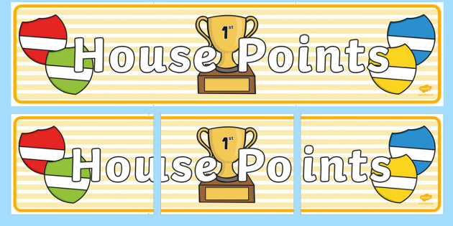

|  |  |  |
| --- | --- | --- |
| **1st** | **Rover** | **181** |
| **11** | **Vauxhall** | **154** |
| **3rd** | **Ford** | **149** |
| **4th** | **Jaguar** | **148** |

**Class Dojo Badges**

**Blue badge** -

50 Class dojos 🔵

**Green badge** -

150 Class dojos 🟢

**Red badge** -

250 Class dojos 🔴

**ACHIEVERS this week are…**

Sienna, Aubree-Leigh, Henry

🔵

Nancy, Violet

🟢



**Jamf**📲

Thank you for your support in the launch of *Learning Futures.*

Parents can now download **JAMF** - the parenting app that allows you to be in control over the children's iPads when at home.

You will be able to create rules and restrictions on the amount of time and the types of apps you would like your child to access at home.

You will first need to download the Jamf App.

This 'How To' video will help you set this up.

<https://www.youtube.com/watch?v=tFAGO_jOk-w>

Please get in touch should you need assistance.



**Happy Birthday!**

**Hugo M!**



**iPad and Home Learning Reminder**

All children were reminded today, in assembly, the amount of time they are expected to spend on home learning after school.

**TTRS** – only 10 minutes at least 3 times a week (Y2-6)

**Maths** – set on Showbie approximately 20 minutes once a week.

**Reading** – approximately 20 minutes on Reading Plus **OR** reading your library book/other reading material at home every day.

**Spellings** – approximately a 10-minute video or spelling words sent via Showbie to practise on paper.

**All other time is at parent’s discretion, and iPads can be locked using Jamf.**

**If you would like support setting up Jamf please let me know.**

LEADERBOARD

1st Year 5

2nd Year 4

3rd Year 6

4th Year 3

5th Year 2

Top Rockers:

Thomas

Rhys

Beau







**PUPIL ABSENCES**

* Please could parents and guardians ensure that any pupil absences are reported to school **via telephone only,** and before 9.30 a.m.
* There is a 24-hour voicemail facility available so there is no need to wait until school opens – you can leave a message at any time.
* Absence messages via Dojo are not accepted as they can easily be missed if the recipient is absent, off site or busy with lessons.

Thank you for your understanding and co-operation 😊