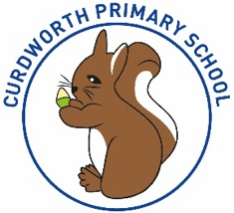

**CPS Newsletter Issue 2**

**Welcome back!**

It has been a fantastic first week back at Curdworth Primary. Those smiles, and giggles throughout the school have been missed. We welcomed 15 new Hedgehogs this week, all of whom have settled in beautifully.

I would like to take this opportunity to thank parents for their incredible patience with the new dinner portal, Relish. Mrs Edwards will continue to work with those families who are still having difficulties with the registration or other.

Next week, phonics teaching and learning will begin for children in Owls Class. Children will be given their first Reading book by the end of the week.

It is very pleasing to see that some children in KS2 have already tried to access their Reading Plus home learning. As baseline assessments need to be completed in school first, we ask children to refrain from reading at home using Reading Plus for the time being.

***Have a lovely weekend in the glorious sun,***

***Mrs Kang & Miss Gibbs ☀️***

**Open Class parent meeting**

We would like to invite all parents to attend the open class parent meeting scheduled for Tuesday 3rd October where you will have the opportunity to look at your child’s learning for the year so far and speak with your child’s class teacher about any concerns or share information you feel useful for us to know.

This will be a free-flowing session where parents are welcome to attend between 5.30-6.30pm and can stay for as long or as short as you like.

**School Dates**

**3.10.23 - 5.30-6.30pm**

Open class parent meeting – *come and view your child’s learning so far, ask questions and learn about school improvement plans.*

**4.10.23** Harvest Donation begins

**9.10.23** Rags2Riches collection day

**10.10.23** Reception 2024 Open Morning tour of the school 9.15-10.15am

**18.10.23** – **2.45pm**

Foxes Class assembly

**24.10.23** Harvest Donations in

**25.10.23** Whole school immunisation

**27.10.23** Harvest Service 2.30pm at St Nicholas’

**HALF TERM**

Mon 30th Oct to Fri 3rd Nov

**INSET DAY** Fri 1st Dec

**CHRISTMAS BREAK**

Mon 25th Dec to Mon 8th Jan

**Happy Birthday!**

Sienna C, Annabelle, Harry, Penny &

Scarlett HR



**ATTENDANCE STARS**

School Target: **97%**

School Actual: 95% 🎉

Best Year Group this week…

☺

**YEAR 4 & Reception**

**Learning Futures**

Deployment day:

Wednesday 20th September

On this day, children will receive their school iPads, cases and chargers. For further support in understanding the Learning Futures initiative check out the following video.

[**https://youtu.be/6XpjdDRRN1Q?feature=shared**](https://youtu.be/6XpjdDRRN1Q?feature=shared)

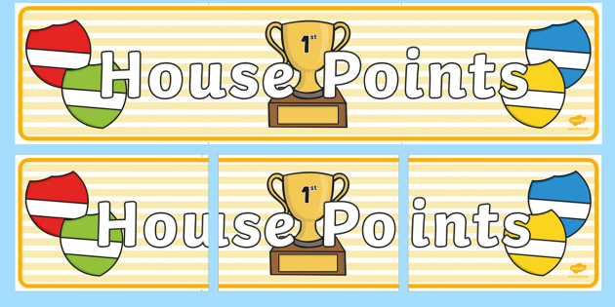

|  |  |  |
| --- | --- | --- |
| **1st** | **Rover** | **109** |
| **2nd** | **Vauxhall** | **108** |
| **3rd** | **Ford** | **103** |
| **4th** | **Jaguar** | **95** |