

**CPS Newsletter Issue 3**

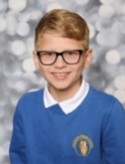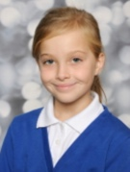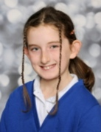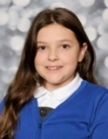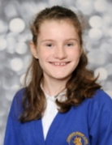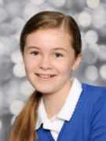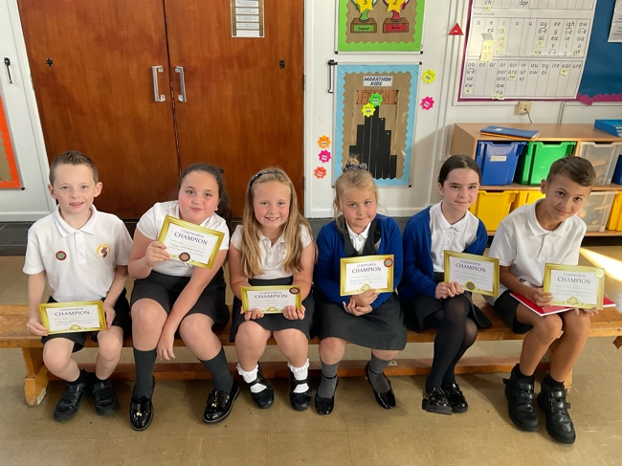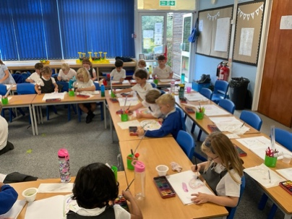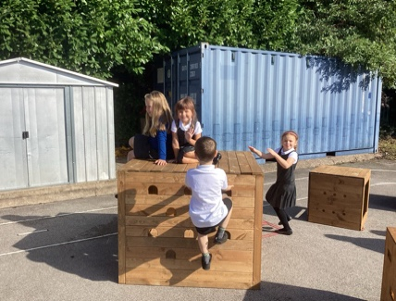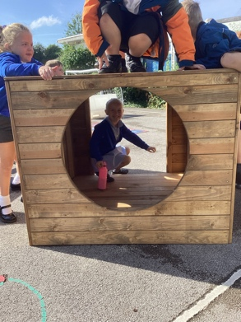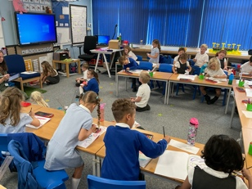

🏆Annabelle🏆

🏆Poppy🏆

🏆Abel🏆

🏆Dolly🏆

🏆Aubree-Leigh🏆

🏆Isaac🏆

Our first Curdworth Champion awards for the year go to..

***News from week 3 at Curdworth Primary…***

We have had a great first full week at Curdworth!

Children have undertaken baseline assessments, started their new topics and new Family Leaders & Deputies have been chosen! Please join me in congratulating the following children for their new roles at Curdworth.

Most parents have now managed to successfully register and are using the Relish portal to book dinners for children. Many of the children have spoken positively about the new menu which is pleasing. We continue to take feedback from the children on the dinners.

Next week, the children’s iPads will be arriving. The iPad launch date has been moved to Thursday 21st September. Children will be coming home with their school iPads, cases and chargers and are expected to bring them into school every day.

***Have a happy weekend,***

***Mrs Kang & Miss Gibbs ☀️***

**Curdworth Champions!**

**Fun in Owls Class this week…**

Owls Class have worked incredibly hard this week and have thoroughly enjoyed using the new playground equipment.

**School Dates**

**3.10.23 - 5.30-6.30pm**

Open class parent meeting – *come and view your child’s learning so far, ask questions and learn about school improvement plans.*

**4.10.23** Harvest Donation begins

**9.10.23** Rags2Riches collection day

**10.10.23** Reception 2024 Open Morning tour of the school 9.15-10.15am

**18.10.23** – **2.45pm**

Foxes Class assembly

**24.10.23** Harvest Donations in

**25.10.23** Whole school immunisation

**27.10.23** Harvest Service 2.30pm at St Nicholas’

**HALF TERM**

Mon 30th Oct to Fri 3rd Nov

**INSET DAY** Fri 1st Dec

**CHRISTMAS BREAK**

Mon 25th Dec to Mon 8th Jan

**Happy Birthday!**

No Birthdays this week!



**ATTENDANCE STARS**

School Target: **97%**

School Actual: 97.6% 🎉

Best Year Group this week…

☺

**Reception with 100%!**

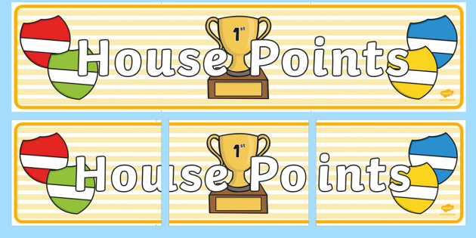

|  |  |  |
| --- | --- | --- |
| **1st** | **Ford** | **219** |
| **2nd** | **Rover** | **212** |
| **3rd** | **Jaguar** | **202** |
| **4th** | **Vauxhall** | **192** |