

**CPS Newsletter Issue 4**

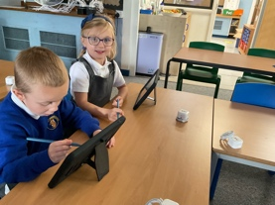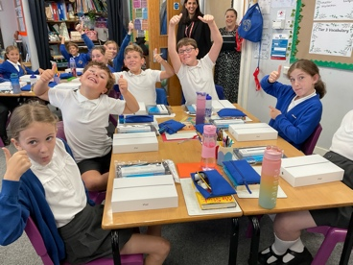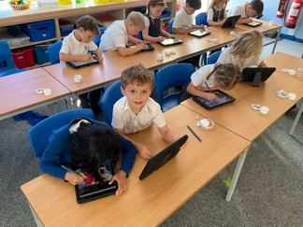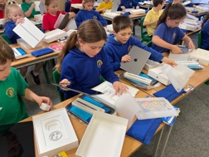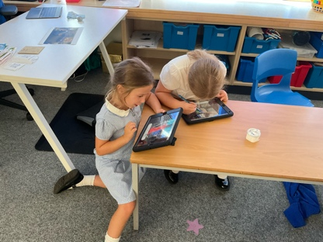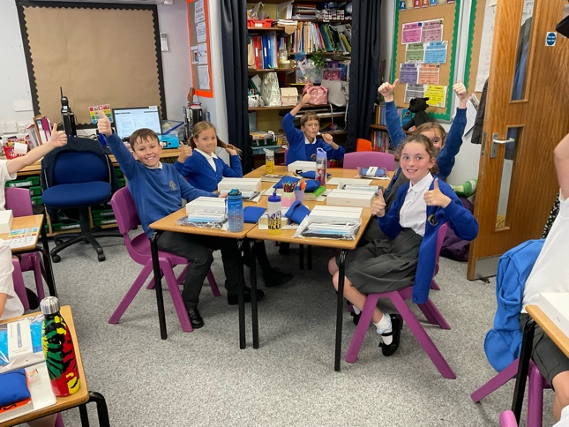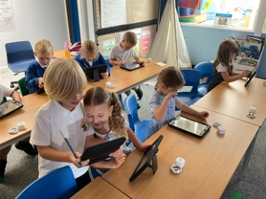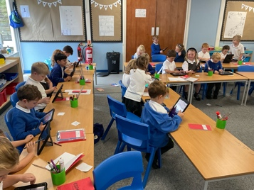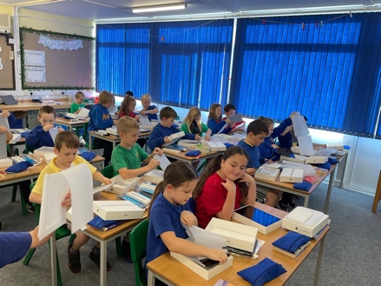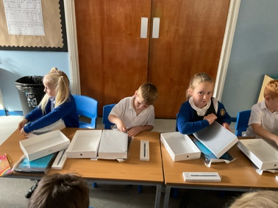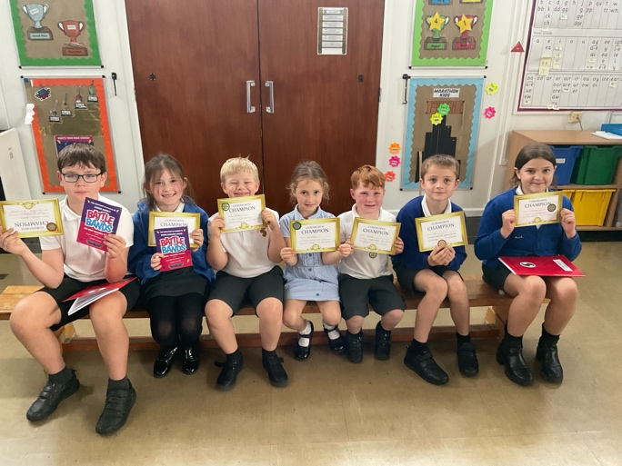

🏆Jenson🏆

🏆Marni🏆

🏆George🏆

🏆Smaranda🏆

🏆Ralph🏆

🏆Will🏆

🏆Jasmine🏆

Curdworth Champion awards this week go to..

**Curdworth Champions!**

***iPad deployment at Curdworth***

It has been a very exciting week for all the children at Curdworth! On Thursday, all children from Year 1 to Year 6 received their very own iPad to enhance their learning at school and at home. They had a complete unboxing experience which involved them opening and setting up their own iPad.

Over the last two days, the children have been exploring how to use different features on the iPad such as how to AirDrop, how to voice record, how to take pictures and many others. They have already begun using them in their lessons which has been brilliant to see.

Next week, we will be sending out further information about the iPads and how you can keep your child safe whilst using them.

Hedgehog children will also begin to use their class set for different activities.

***Have a happy weekend,***

***Mrs Kang & Miss Gibbs ☀️***

**ATTENDANCE STARS**

School Target: **97%**

School Actual: 95.4 % 🎉

Best Year Group this week…

☺

**Year 2 with 100%**

**Happy Birthday!**

**Lilly and Sophie W!**



**School Dates**

**3.10.23 - 5.30-6.30pm**

Open class parent meeting – *come and view your child’s learning so far, ask questions and learn about school improvement plans.*

**4.10.23** Harvest Donation begins

**9.10.23** Rags2Riches collection day

**10.10.23** Reception 2024 Open Morning tour of the school 9.15-10.15am

**18.10.23** – **2.45pm**

Foxes Class assembly

**24.10.23** Harvest Donations in

**25.10.23** Whole school immunisation and Y1 and Y5 Fire Service Presentation

**27.10.23** Harvest Service 2.30pm at St Nicholas’

**HALF TERM**

Mon 30th Oct to Fri 3rd Nov

**INSET DAY** Fri 1st Dec

**CHRISTMAS BREAK**

Mon 25th Dec to Mon 8th Jan

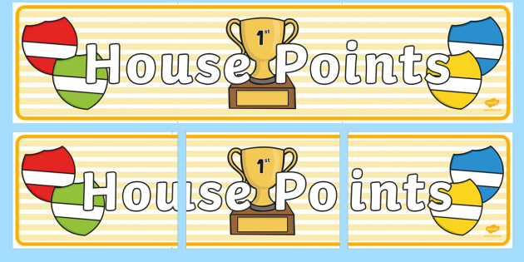

|  |  |  |
| --- | --- | --- |
| **1st** | **Rover** | **228** |
| **2nd** | **Ford** | **219** |
| **3rd** | **Vauxhall** | **218** |
| **4th** | **Jaguar** | **215** |