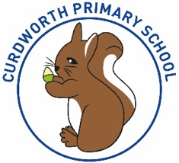

**CPS Newsletter Issue 6**

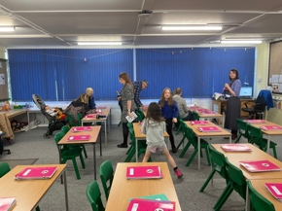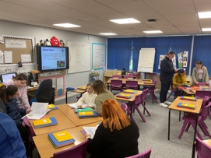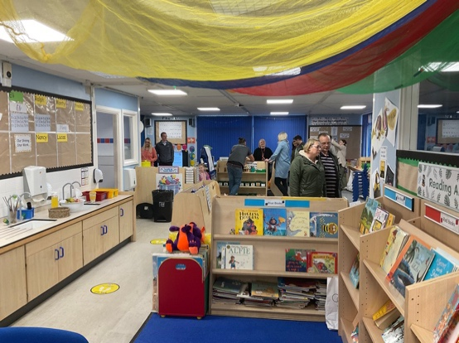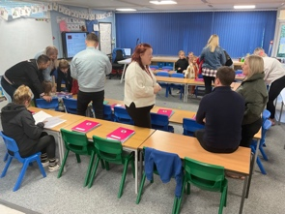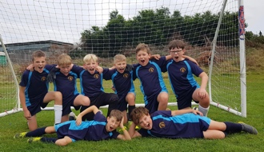

**Happy Birthday!**

Tristan & Jenson



**What’s been happening at Curdworth this week….**

**Razzmatazz**

This week Foxes class took part in a complimentary workshop ran by Razzmatazz where children embraced their singing, dancing and acting skills!

**Squirrels Football Tournament**

Rhys, Brodie, Bobby-Jo, Oliver, Ostap,

Jenson, Felix, Jake and Hugo from

Squirrels class did the school proud

this Thursday at the first football

tournament of the school year. They won one game and as you can see by the photo, had a great time! 😃

**Open Parent Evening**

It was great seeing so many parents turn up on Tuesday to celebrate children’s learning so far, to speak with class teachers about successes, targets and general information about our brilliant children. Speaking to most of you, I am pleased you found the evening supportive and useful. The formal parents evening is scheduled to take place next half term, as normal.

**Dinner payments**

I am aware some MCAS accounts are not being charged for school dinners. This error is currently being addressed and I recommend parents to continue to top up their MCAS accounts to cover the dinners you have been ordering so far.

***Have a wonderful weekend,***

***Mrs Kang & Miss Gibbs ☀️***

**School Dates**

**9.10.23** Rags2Riches collection day

**10.10.23** Reception 2024 Open Morning tour of the school 9.15-10.15am

**18.10.23** – **2.45pm**

Foxes Class assembly

**24.10.23** Harvest Donations in

**25.10.23** Whole school immunisation and Y1 and Y5 Fire Service Presentation

**26.10.23** 👻Halloween Disco 5-7pm 🎃

**27.10.23** Harvest Service 2.30pm at St Nicholas’

**HALF TERM**

Mon 30th Oct to Fri 3rd Nov

**6.11.23** School Reopens & School Photos – individual and siblings 📸

**9.11.23** Y1 Phonics Parent Workshop 9-9.45am

**10.11.23** Remembrance WOW Day

**13.11.23** Anti-Bullying Week starts

**20.11.23** Odd Sock Day & Reception Vision Screening; Parent Consultation bookings scheduled to open

**23.22.23** Phonics Parent Workshop 9-9.45am

**INSET DAY** Fri 1st Dec

**CHRISTMAS BREAK**

Mon 25th Dec to Mon 8th Jan

**Curdworth Champions!**

Curdworth Champion awards this week go to...

🏆Jobe🏆

🏆Oakley🏆

🏆Siena🏆

🏆Penny🏆

🏆Bodhi🏆

🏆Noelia🏆

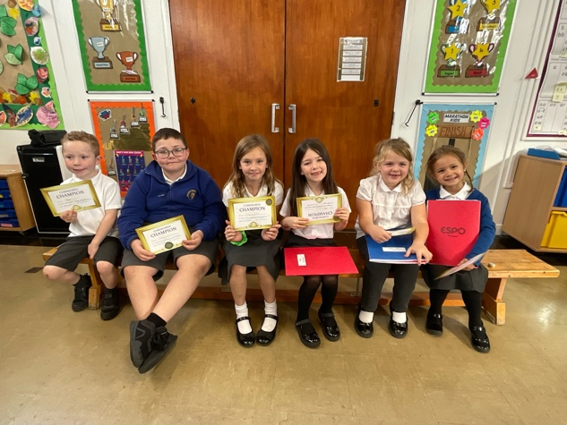

**⭐️ATTENDANCE STARS ⭐️**

School Target: **97%**

School Actual: **93.8%**

Best Year Group this week…

☺

**Yr 2 with 100%**

**Jamf**📲

Thank you for your support in the launch of *Learning Futures.*

Parents can now download **JAMF** - the parenting app that allows you to be in control over the children's iPads when at home.

You will be able to create rules and restrictions on the amount of time and the types of apps you would like your child to access at home.

You will first need to download the Jamf App.

This 'How To' video will help you set this up.

<https://www.youtube.com/watch?v=tFAGO_jOk-w>

Please get in touch should you need assistance.

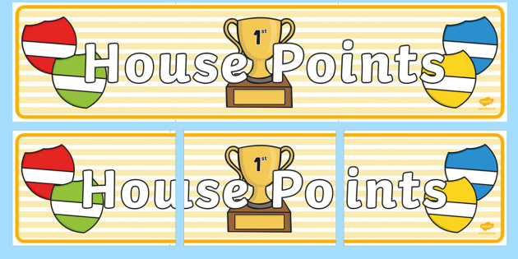

|  |  |  |
| --- | --- | --- |
| **1st** | **Jaguar** | **194** |
| **2nd** | **Ford** | **174** |
| **3rd** | **Vauxhall** | **173** |
| **4th** | **Rover** | **160** |

**Class Dojo Badges**

**Blue badge** -

50 Class dojos 🔵

**Green badge** -

150 Class dojos 🟢

**Red badge** -

250 Class dojos 🔴

**ACHIEVERS last week were…**⭐️

🔵Sophie B, Ralph & Jobe!

**ACHIEVERS this week are…**

Billy, Violet, Teddy, Isaiah, Imogen, Charlie S, Nancy, Tiago, Freddie, Sophie P, Monty, Lucas, Jay, Honey-Bow

🔵



**Whole School Immunisation - Flu😷**

Parents must complete the

consent form for each child

by 15th October.

Please follow the link or scan

the QR code.

**Unique consent link:** <https://iv.covwarkpt.nhs.uk/form?identifier=1a16ab13-964d-4287-ab75-433f555de2d4>

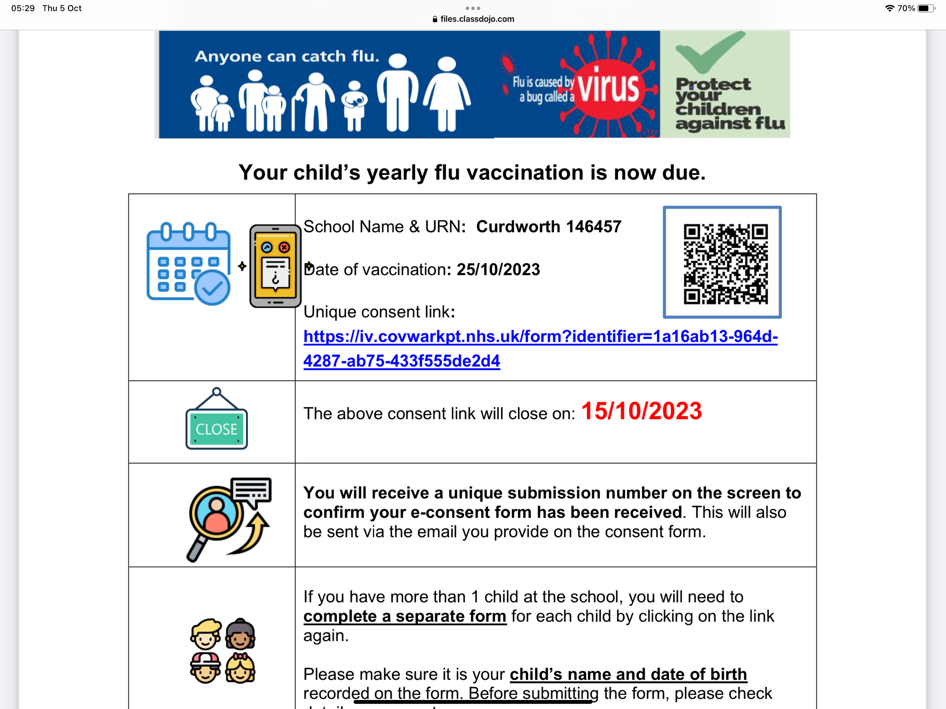

SPECIAL MENTIONS 📣

Congratulations this week goes

to Victoria for her appearance

at the Horse of the Year Show.

Victoria’s horse came in

Second place in the competition

& was Reserve Champion!

🎊 WELL DONE, VICTORIA!

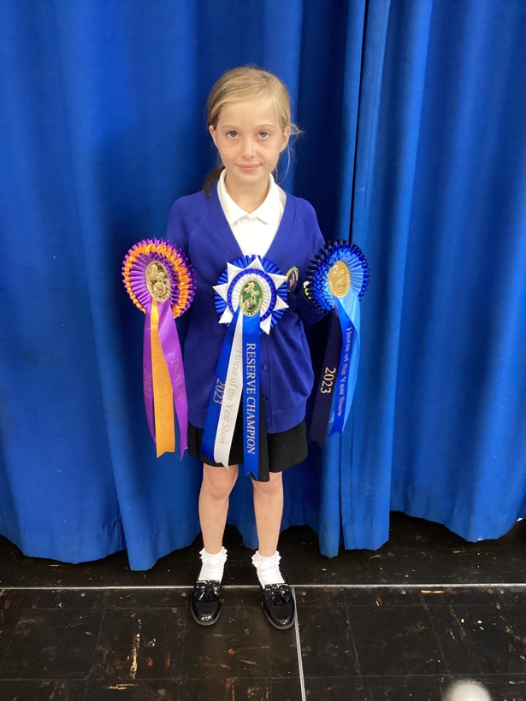

LEADERBOARD

1st Year 5

2nd Year 4

3rd Year 6

4th Year 3

Top Rockers:

Chloe

Sophie W

Rhys-David





**ATLP School Centred Initial Teacher Training**

**Open Evening: Thursday 5th October, 6pm to 8pm**

Are you interested in becoming a teacher and want to find out more?

Whether you are just graduating or you are looking to change careers, find out how we can support you on your journey to becoming a teacher.

We will be hosting our first Open Event of the academic year on Thursday 5th October, 6pm to 8pm, at Arthur Terry School.

This is a great opportunity for you to meet the team, find out more information and ask any questions you may have about becoming a teacher.

More information can be found on our website, as well as registration information; [Teacher Training | Open Events - Arthur Terry Teaching School (atlp.org.uk)](https://eur03.safelinks.protection.outlook.com/?url=https%3A%2F%2Farthurterryteachingschool.atlp.org.uk%2Ftrain-to-teach%2Fscitt-open-events%2F&data=05%7C01%7Ckang.j%40curdworth.warwickshire.sch.uk%7Ce8a9a20725464f6d0ee408dbc31b403b%7C645473a262c54bab8a6d837c0d96587c%7C1%7C0%7C638318294037985797%7CUnknown%7CTWFpbGZsb3d8eyJWIjoiMC4wLjAwMDAiLCJQIjoiV2luMzIiLCJBTiI6Ik1haWwiLCJXVCI6Mn0%3D%7C3000%7C%7C%7C&sdata=gRWaGZsksITXhdONwxVh0RLZdwiia6Ki5KlInmSgioY%3D&reserved=0).

***🎃PTFA Halloween DISCO🎃***

On behalf of the PTFA, we will be holding a Halloween Disco on Thursday 26 October.

This is available for all children. Drop off will be 5pm and collection at 7pm from the main entrance of the school.

Refreshments will be available to purchase on the evening.

Tickets will be £5 each. Please send your child to school with it in a named envelope or give to me (Claire Winters) at the gate.

***OTHER PTFA EVENTS RELEASED SOON…***

🎄 Christmas Fair Thursday 7th December 2023 3.30-5pm; 🎥 Movie Afternoon Thursday 1st February; 🪩Summer Ball Thursday 16th May 5-7pm; 🎠Summer Fayre Thursday 4th July 2-4pm