

**CPS Newsletter Issue**

**Happy Birthday!**

No birthdays this week



**What’s been happening at Curdworth this week….**

**School council**

**Family leader photos**

**Cross Country tournament**

***Have a wonderful weekend,***

***Mrs Kang & Miss Gibbs ☀️***

**School Dates**

**18.10.23** – **2.45pm**

Foxes Class assembly

**24.10.23** Harvest Donations in

**25.10.23** Whole school immunisation and Y1 and Y5 Fire Service Presentation

**26.10.23** 👻Halloween Disco 5-7pm **🎃See Dojo for more info**

**27.10.23** Harvest Service 2.30pm at St Nicholas’

**HALF TERM**

Mon 30th Oct to Fri 3rd Nov

**6.11.23** School Reopens & School Photos – individual and siblings 📸

**9.11.23** Y1 Phonics Parent Workshop 9-9.45am

**10.11.23** Remembrance WOW Day

**13.11.23** Anti-Bullying Week starts

**20.11.23** Odd Sock Day & Reception Vision Screening; Parent Consultation bookings scheduled to open

**23.11.23** Phonics Parent Workshop 9-9.45am

**28.11.23** Reception Open morning 9.15-10.15

**29.11.23** Whole School Panto Trip

**30.11.23** Squirrels Class assembly

**INSET DAY** Fri 1st Dec

**CHRISTMAS BREAK**

Mon 25th Dec to Mon 8th Jan

**Curdworth Champions!**

Curdworth Champion awards this week go to...

🏆Lucas🏆

🏆Victoria🏆

🏆Daryna🏆

🏆Phoenix B🏆

🏆Owls Class🏆

**⭐️ATTENDANCE STARS ⭐️**

School Target: **97%**

School Actual: 92.5**%**

Best Year Group this week…

☺

**Yr 5 with 100%**

**Jamf**📲

Thank you for your support in the launch of *Learning Futures.*

Parents can now download **JAMF** - the parenting app that allows you to be in control over the children's iPads when at home.

You will be able to create rules and restrictions on the amount of time and the types of apps you would like your child to access at home.

You will first need to download the Jamf App.

This 'How To' video will help you set this up.

<https://www.youtube.com/watch?v=tFAGO_jOk-w>

Please get in touch should you need assistance.

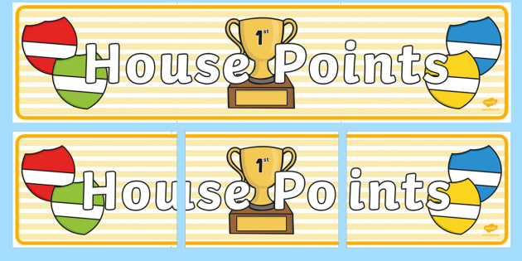

|  |  |  |
| --- | --- | --- |
| **1st** | **Rover** | **241** |
| **2nd** | **Ford** | **220** |
| **3rd** | **Vauxhall** | **193** |
| **4th** | **Jaguar** | **157** |

**Class Dojo Badges**

**Blue badge** -

50 Class dojos 🔵

**Green badge** -

150 Class dojos 🟢

**Red badge** -

250 Class dojos 🔴

**ACHIEVERS this week are…**

Justin, Myla, Poppy, Millen, Phoenix B, Alexandra, Hugo M, Rhys, Felix, Jenson, Ostap, Oliver, Beau, Bobby-Jo

🔵

Well done children! I wonder who will receive the first green badge! 🟢



**Whole School Immunisation - Flu😷**

Parents must complete the

consent form for each child

by 15th October.

Please follow the link or scan

the QR code.

**Unique consent link:** <https://iv.covwarkpt.nhs.uk/form?identifier=1a16ab13-964d-4287-ab75-433f555de2d4>

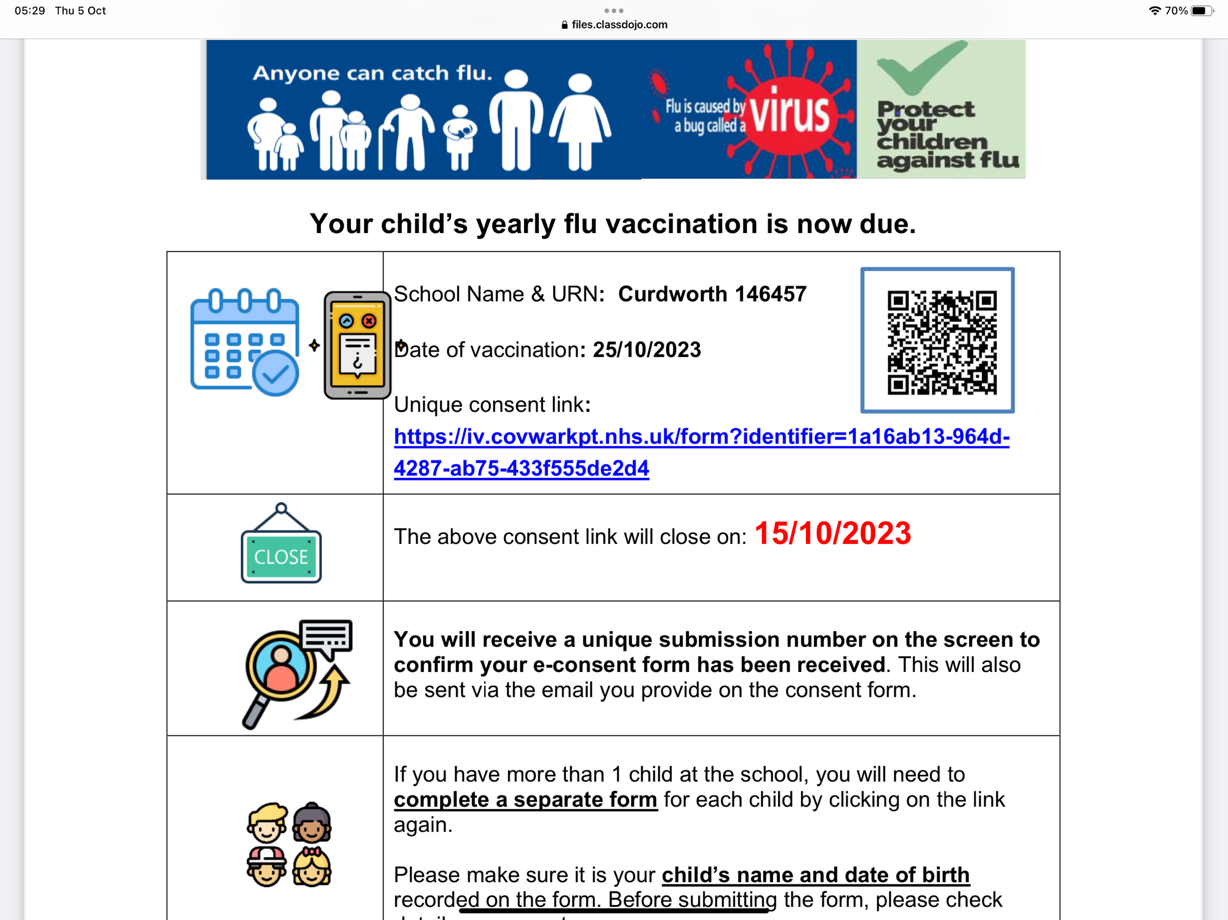

SPECIAL MENTIONS 📣

LEADERBOARD

1st Year 5

2nd Year 6

3rd Year 4

4th Year 3

Top Rockers:

Rhys

Ostap

Bethany





**School Council**

***🎃PTFA Halloween DISCO🎃***

On behalf of the PTFA, we will be holding a Halloween Disco on *Thursday 26 October*.

This is available for all children. Drop off will be 5pm and collection at 7pm from the main entrance of the school.

Refreshments will be available to purchase on the evening.

Tickets will be £5 each. Please send your child to school with it in a named envelope or give to me (Claire Winters) at the gate.

**THIS IS A FANCY DRESS PARTY! 😊**

***OTHER PTFA EVENTS RELEASED SOON…***

🎄 Christmas Fair Thursday 7th December 2023 3.30-5pm; 🎥 Movie Afternoon Thursday 1st February; 🪩Summer Ball Thursday 16th May 5-7pm; 🎠Summer Fayre Thursday 4th July 2-4pm