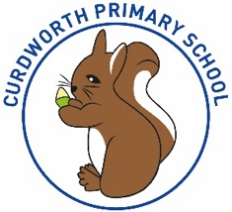

**CPS Newsletter Issue 8**

..

***🎃PTFA Halloween DISCO🎃***

***THURSDAY 26TH NOVEMBER***

***5PM – 7PM***

***Drop off and collection through main school entrance.***

**THIS IS A FANCY DRESS PARTY! 😊**

*See Mrs Winters for further information.*

**What’s been happening at Curdworth this week….**

**Foxes Class Assembly**

On Wednesday, Foxes class put on a fantastic class assembly for all their parents and the children in school. All children worked hard over the last couple of weeks to put this together and their hard work really paid off! It was great to see the children showing confidence in sharing their learning and all the adults we so proud of them 😃.

***Harvest Service – Thursday 26TH October***

On Thursday, children will be attending Harvest Service at St Nicholas’ Church at 2.30pm. We invite parents to attend. Please note that seating is limited to only half of the church for parents, as children and school staff will be occupying the first half. Some parents may be required to stand.

At 3pm the service will end. If you do decide to join us, you will be able to take your child home from the church. If you are unable to attend, do not worry, we will walk children back to school for normal pick-up time of 3.15pm.

To support, we advise children not to bring iPads or bags to school on Thursday. All they will need is their coat, lunch - if home dinners - and their water bottles.

***Have a wonderful weekend,***

***Mrs Kang & Miss Gibbs ☀️***

**School Dates**

**24.10.23** Harvest Donations in

**25.10.23** Whole school immunisation and Y1 and Y5 Fire Service Presentation

**26.10.23** 👻Halloween Disco 5-7pm

**27.10.23** Harvest Service 2.30pm at St Nicholas’

**HALF TERM**

Mon 30th Oct to Fri 3rd Nov

**6.11.23** School Reopens & School Photos – individual and siblings 📸

**9.11.23** Y1 Phonics Parent Workshop 9-9.45am

**10.11.23** Remembrance WOW Day

**13.11.23** Anti-Bullying Week starts.

**20.11.23** Odd Sock Day

Reception Vision Screening

Parent Consultation bookings scheduled to open.

**23.11.23** Phonics Parent Workshop 9-9.45am

**28.11.23** Reception Open morning 9.15-10.15

**29.11.23** Whole School Panto Trip

**30.11.23** Squirrels Class assembly

**INSET DAY** Fri 1st Dec.

**CHRISTMAS BREAK**

Mon 25th Dec to Mon 8th Jan

Children return Tuesday 9th Jan 2024

**Happy Birthday!**

Honey-Bow and Samuel



**Curdworth Champions!**

Curdworth Champion awards this week go to...

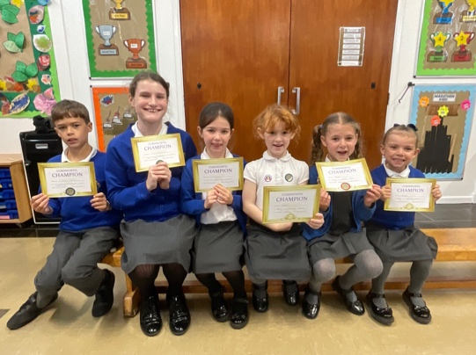

🏆Isaiah🏆

🏆Sophie W🏆

🏆Foxes Class🏆

🏆Jessica🏆

🏆Harper🏆

🏆Imogen🏆

**⭐️ATTENDANCE STARS ⭐️**

School Target: **97%**

School Actual: **95.8%**

Best Year Group this week…

**Year 1 with 100% 😊**

**Jamf**📲

Thank you for your support in the launch of *Learning Futures.*

Parents can now download **JAMF** - the parenting app that allows you to be in control over the children's iPads when at home.

You will be able to create rules and restrictions on the amount of time and the types of apps you would like your child to access at home.

You will first need to download the Jamf App.

This 'How To' video will help you set this up.

<https://www.youtube.com/watch?v=tFAGO_jOk-w>

Please get in touch should you need assistance.

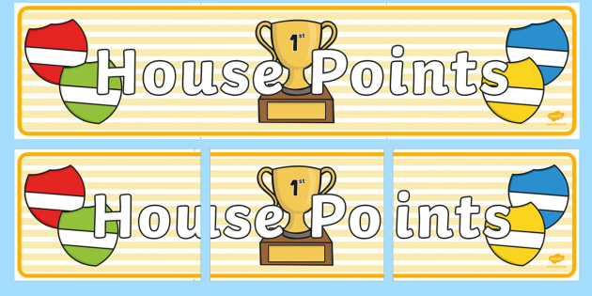

|  |  |  |
| --- | --- | --- |
| **1st** | **Vauxhall** | **229** |
| **2nd** | **Rover** | **207** |
| **3rd** | **Ford** | **206** |
| **4th** | **Jaguar** | **185** |

**Class Dojo Badges**

**Blue badge** -

50 Class dojos 🔵

**Green badge** -

150 Class dojos 🟢

**Red badge** -

250 Class dojos 🔴

**ACHIEVERS this week are…**

Elijah, Noelia, Isla G, Jesse G, Annabelle, Paul, Hugo L, Rory, Florence V, Avery, Siena W, Roman, Jake Oakley & Isaac 🔵

Well done children! I wonder who will receive the first green badge! 🟢



**iPad and Home Learning Reminder**

All children were reminded today, in assembly, the amount of time they are expected to spend on home learning after school.

**TTRS** – only 10 minutes at least 3 times a week (Y2-6)

**Maths** – set on Showbie approximately 20 minutes once a week.

**Reading** – approximately 20 minutes on Reading Plus **OR** reading your library book/other reading material at home every day.

**Spellings** – approximately a 10-minute video or spelling words sent via Showbie to practise on paper.

**All other time is at parent’s discretion, and iPads can be locked using Jamf.**

**If you would like support setting up Jamf please let me know.**

LEADERBOARD

1st Year 5

2nd Year 4

3rd Year 3

4th Year 6

Top Rockers:

Henry

Rhys

Chloe







