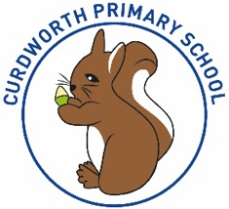

**CPS Newsletter Issue 9**

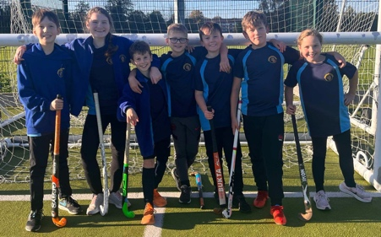

**Happy Birthday!**

Indie and Sophie P



**School Dates**

**HALF TERM**

Mon 30th Oct to Fri 3rd Nov

**6.11.23 School Reopens & School** Photos – individual and siblings 📸

**7.11.23** Squirrels Loudmouth Workshop

**9.11.23** Y1 Phonics Parent Workshop 9-9.45am

**10.11.23** Remembrance WOW Day & Remembrance Exhibition 2.15-3.15 (parents invited)

**13.11.23** Anti-Bullying Week starts.

**20.11.23** Odd Sock Day

Reception Vision Screening

Parent Consultation bookings scheduled to open.

**NEW DATE** Reception Open morning 9.15-10.15

**23.11.23** Phonics Parent Workshop 9-9.45am

**28.11.23** Reception Open morning 9.15-10.15

**29.11.23** Whole School Panto Trip

**30.11.23** Squirrels Class assembly

**INSET DAY** Fri 1st Dec.

**CHRISTMAS BREAK**

Mon 25th Dec to Mon 8th Jan

Children return Tuesday 9th Jan 2024

**What has been happening at Curdworth this week….**

As our first half term comes to an end, I think about all that the pupils, staff and school community have been a part of over the last 8 weeks. The children’s success at school will continue to be driven by high expectations, offering an innovative and ambitious curriculum routed by nurture, clear routines and a *respectful*, *safe,* and *ready* to learn environment.

**Hockey competition 🏑**

On Wednesday, seven children

from Squirrels class represented

Curdworth at the North

Warwickshire hockey competition.

All children participated with

great enthusiasm and demonstrated fantastic teamwork skills. They came 3rd overall in the competition!

**School disco 🎃**

The Halloween disco was a great success! All the children looked fabulous in their costumes and had a brilliant time. They enjoyed joining in with the games and being able to dance with their friends. We had 100 children in attendance which was fantastic!

**Harvest Service**

We look forward to seeing some of you at the Harvest Service later this afternoon! As at previous events at the church, we will ask parents to vacate first and dismiss children after. A reminder that children do not have to be collected from the church as we aim to be back at school at 3.15pm for normal school pick up time.

**School Photos – Monday 6th November**

On the first day back, it is sibling and individual photo day. Please ensure children attend in correct school uniform. Families who have young children outside of Curdworth Primary are welcome to have their school sibling photo first, at 8.45am. Please wait in the school reception to be called through.

***We would like to wish all children and families a wonderful half-term break, Mrs Kang & Miss Gibbs ☀️***

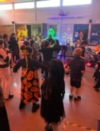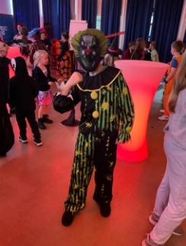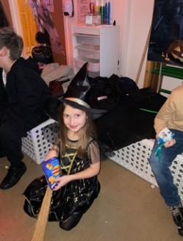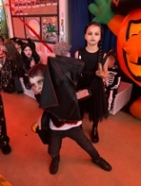

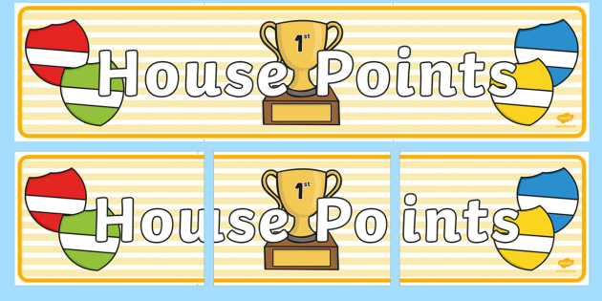

|  |  |  |
| --- | --- | --- |
| **1st** | **Ford** | **245** |
| **2nd** | **Rover** | **241** |
| **3rd** | **Vauxhall** | **219** |
| **4th** | **Jaguar** | **171** |

**⭐️ATTENDANCE STARS ⭐️**

School Target: **97%**

School Actual: **97.2%**

Best Year Group this week…

**Reception with 100% 😊**

**Class Dojo Badges**

**Blue badge** -

50 Class dojos 🔵

**Green badge** -

150 Class dojos 🟢

**Red badge** -

250 Class dojos 🔴

**ACHIEVERS this week are…**

Ismael, Yvie, Lilly, Sienna C, Victoria, Brodie, Chloe, Daryna, William, Ivie-Mai, Minnie, Florence M, Ada, Bodhi, Ivy, Jessica, Jax & Smaranda

*They will receive their badges in the assembly after half term.*

🔵

Well done children! I wonder who will receive the first green badge! 🟢

*Teddy G, you’re almost there!*

**Jamf**📲

Thank you for your support in the launch of *Learning Futures.*

Parents can now download **JAMF** - the parenting app that allows you to be in control over the children's iPads when at home.

You will be able to create rules and restrictions on the amount of time and the types of apps you would like your child to access at home.

You will first need to download the Jamf App.

This 'How To' video will help you set this up.

<https://www.youtube.com/watch?v=tFAGO_jOk-w>

Please get in touch should you need assistance.





**iPad and Home Learning Reminder**

All children were reminded today, in assembly, the amount of time they are expected to spend on home learning after school.

**TTRS** – only 10 minutes at least 3 times a week (Y2-6)

**Maths** – set on Showbie approximately 20 minutes once a week.

**Reading** – approximately 20 minutes on Reading Plus **OR** reading your library book/other reading material at home every day.

**Spellings** – approximately a 10-minute video or spelling words sent via Showbie to practise on paper.

**All other time is at parent’s discretion, and iPads can be locked using Jamf.**

**If you would like support setting up Jamf please let me know.**

***A message from Laura Heeley***

*“I’m Laura Heeley, your community advocate at Curdworth School. Our school advocates have already met this term to discuss areas for improvement – we are passionate about listening to feedback and one of our areas of focus is to improve communication between our school, parents, and pupils.  Communication is key to ensuring that our school and our community feel connected. We will shortly be introducing a Parent Council to advocate our parents’ voice alongside our school’s usual open-door policy.  More information will be released next term so please watch this space and get involved if you can! Our advocates meet regularly throughout the year so please talk to us about any questions or ideas that you may have.”*

LEADERBOARD

1st Year 5

2nd Year 4

3rd Year 6

4th Year 3

Top Rockers:

Rhys

Hugo M

Ostap



